Venue Request Form: ALUMNI MEETING ROOM
Contact Details
Faculty/Department:
Contact Name:
E-mail:
Date:

Booking Details
Name of Meeting:
Purpose of meeting:
Date of Booking:
Meeting Start Time:
Meeting End Time:

Setup/ Access Time:

Colleagues please note that venue is available to view before booking is made.

After reading document
I agree to terms and conditions

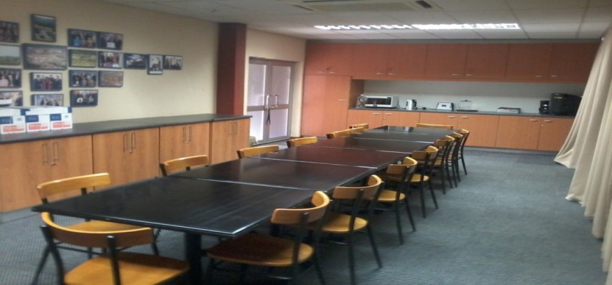

Venue Details
The Alumni Meeting Room can only seat a maximum of 16 people. A Data Screen is available in the venue as well as a flipchart that can be use.
Please take note of the following:
- Venue is to be left as found after the meeting
- Only the meeting room entrance door is to be used not the office door
- A person is to be assigned to welcome guest, as we are an office who is busy as well and cannot take responsibility to welcome guest
- No cupboards is too be open during meeting as it is ALUMNI property
- If extra furniture or equipment is needed the person in charge is to arrange that with support services. Furniture/ equipment are to be dropped and collected after meeting.
- We are still an open office and we request that noise level is too be controlled

Audio and Visual Aid
All audio and visual equipment is too be organized by person in charge from media services. We do not take any responsibility for equipment being used.
Please arrange for collection of equipment straight after meeting.
Catering Requirements
Catering is to be done by person in charge. Please arrange with caterers too collect cutlery straight after the meeting.

Thank you for you co-operation for any further questions contact Mr F. Martins at Fredwin.Martins@nmmu.ac.za
041 504 3935

